Requests & Responses
Example 1:- We can access the information contained in the request (req) object by passing it into the createServer() callback. When we refresh localhost:3000, the browser sends a new request, and we can inspect req to see useful information such as the HTTP method, URL, headers, and other request details.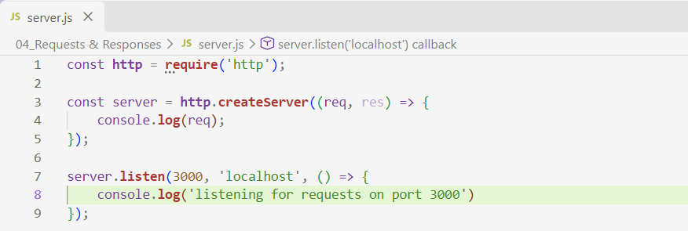
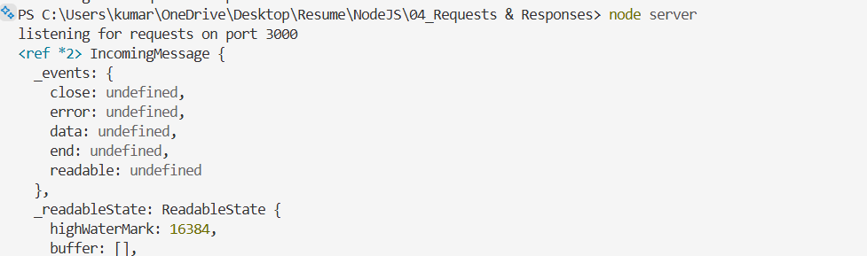
The syntax of createServer() is:-
http.createServer((req, res) => {
// handle request
// send response
});

The syntax of listen() is:- server.listen(port, hostname, callback);

Example 2:-
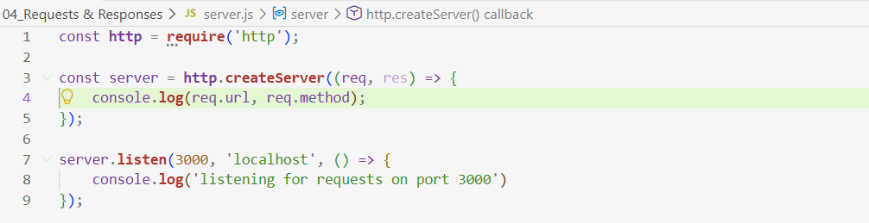
When we use req.url, it gives us the URL path requested by the client. If we open localhost:3000, the path is /. If we open localhost:3000/about, req.url will return /about. The req.method property tells us the HTTP method used for the request; when we access these URLs directly through the browser, it will normally be GET.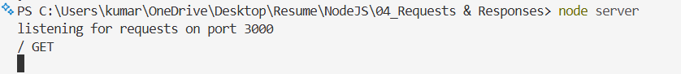 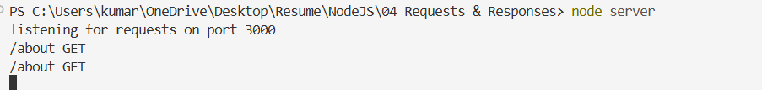
Right now, our server is not sending any meaningful response to the client because we haven't added any response logic using res. We need to use the response (res) object to send some content back to the browser.
Example 3:- Since we are sending a simple text response, we specify the Content-Type as text/plain. This tells the browser that the response body contains plain text rather than HTML, JSON, or another type of content. 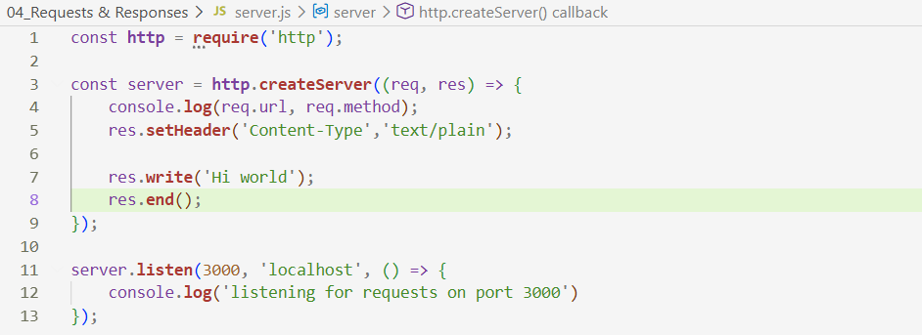
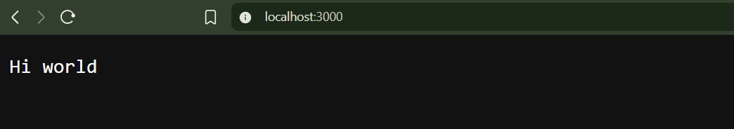
The syntax of setHeader() is:- res.setHeader("Header-Name", "value");

The response contains the information we sent from the server along with additional HTTP response headers, such as Date, Connection, and Keep-Alive. We can view these details by opening the browser's Developer Tools → Network tab, selecting the localhost request, and inspecting its response headers.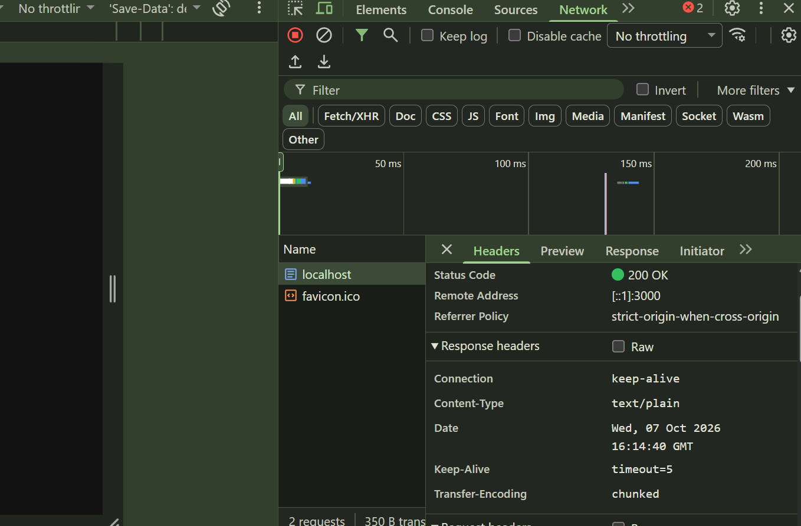

Example 4:- We can set the Content-Type to text/html when we want to send an HTML response containing elements such as <p>, <head>, and <body>. The browser will parse the response as HTML and render the elements accordingly. If we provide our own HTML structure, the browser parses and renders the structure we send instead of treating the content as plain text.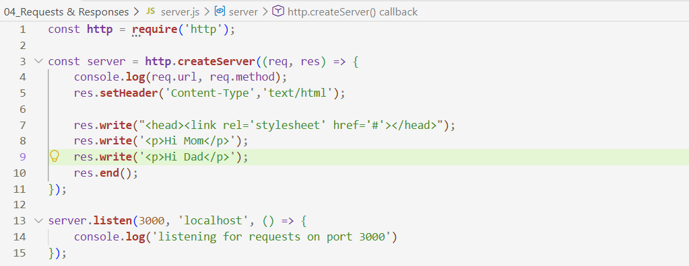

We can see the values and content we wrote inside the <p>, <head>, and other HTML tags when the browser renders the response.
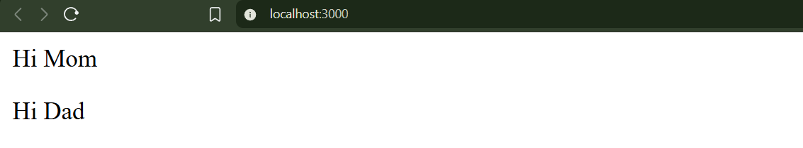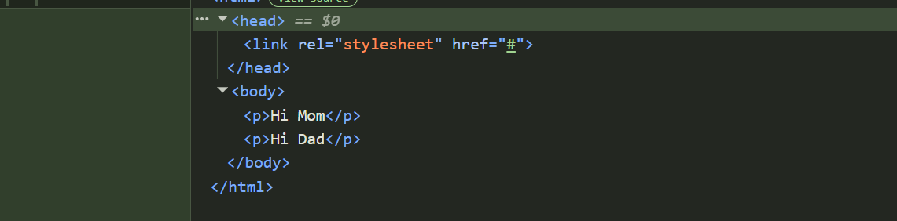

Example 6:- We cannot realistically write the entire HTML code manually using res.write() every time. Instead, we can create a separate HTML file and read its contents when a request arrives. We use Node.js's File System (fs) module to read the HTML file and send its contents as the response.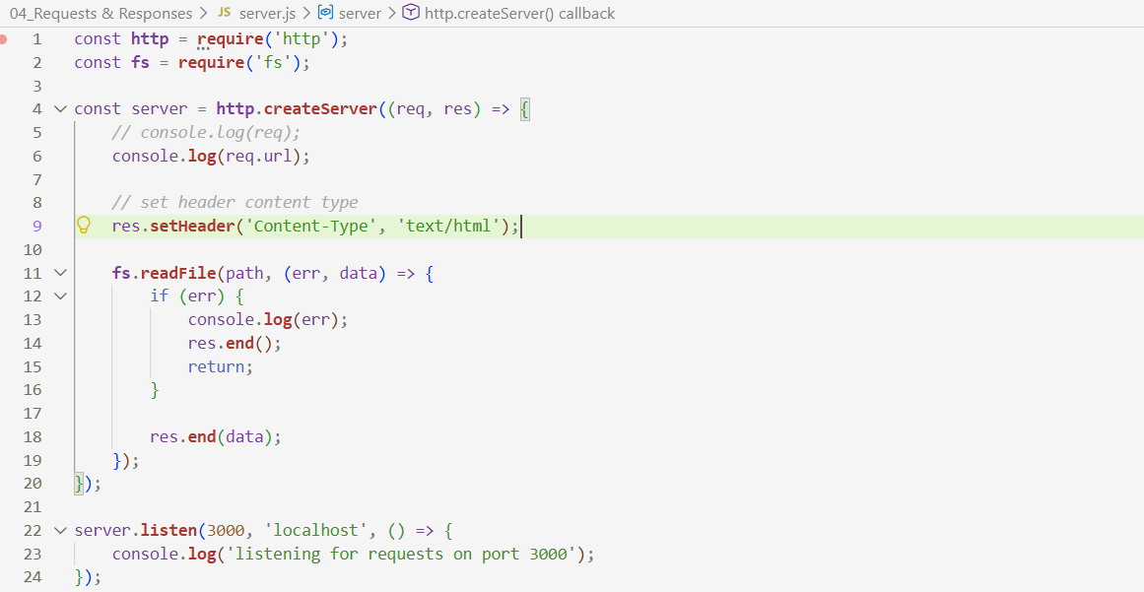
Since we are sending the data as a single response, we don’t need to use res.write(data). We can directly use res.end(data). res.end() can send the final response body and close the response. However, if we need to send the response in multiple chunks, we would use res.write() followed by res.end().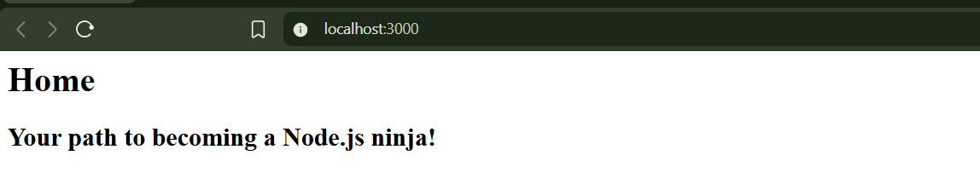

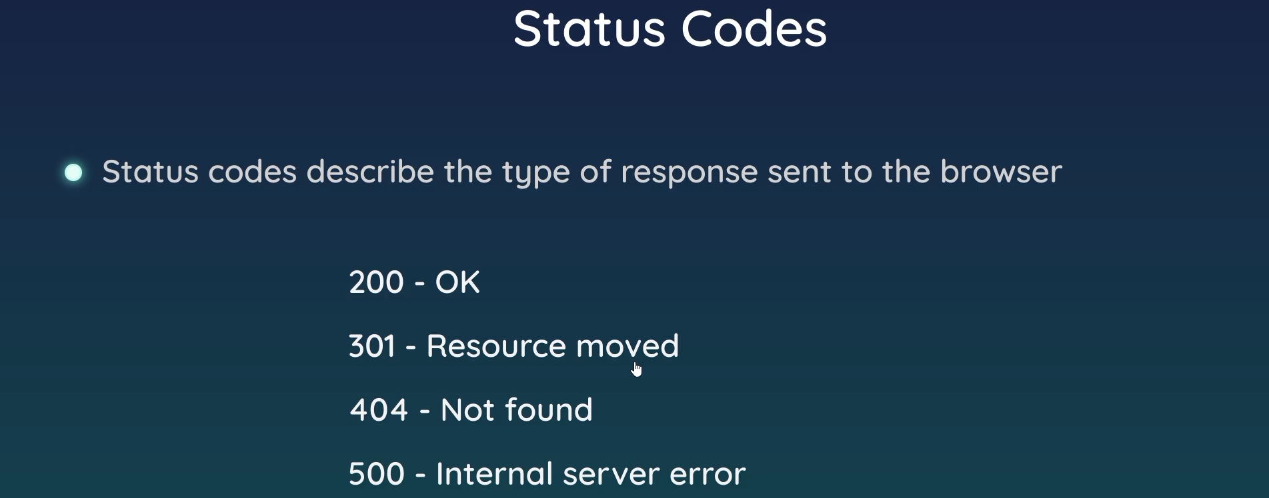

Example 7:- Here, we create a path variable based on the URL requested by the client. If the URL is /, we serve index.html. If it is /about, we serve about.html. For any other unknown route, we serve 404.html.
The main change is that instead of passing a fixed file path to fs.readFile(), we pass the dynamically determined path variable. We also set different HTTP status codes depending on the requested route—for example, 200 for valid pages and 404 for an unknown route. These status codes can be viewed in the browser's Inspect → Network tab.
We also redirect /about-me to /about using res.setHeader('Location', './about') along with the appropriate redirect status code. Finally, res.end() ends the response.
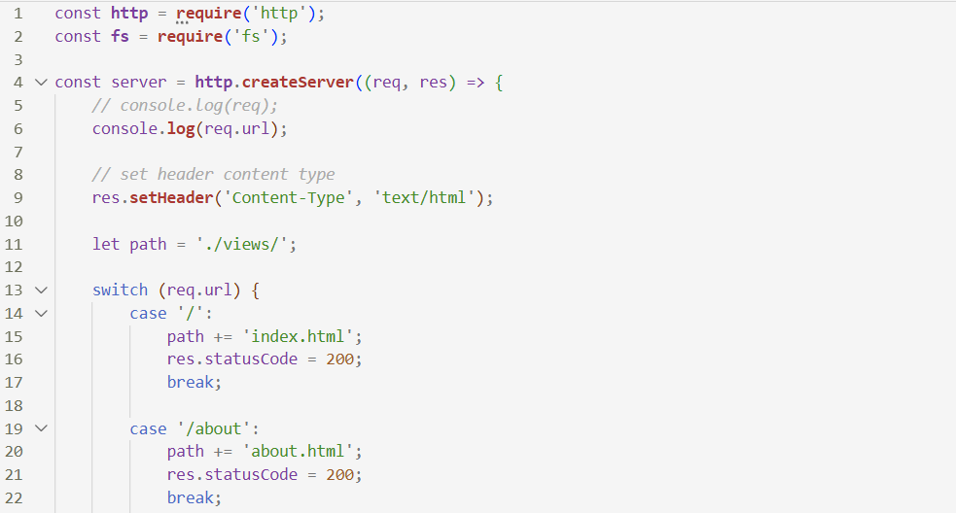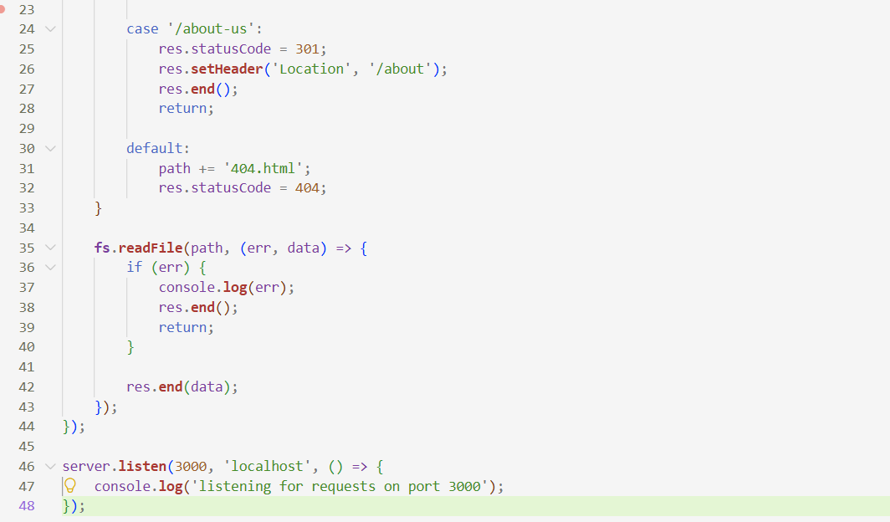
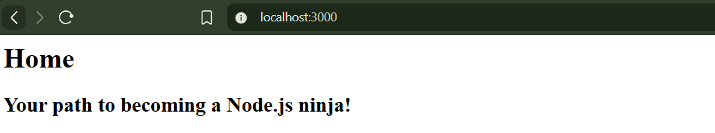

Important res.setHeader() syntaxes :-
// 1. Content type
res.setHeader('Content-Type', 'text/html');

// 2. JSON
res.setHeader('Content-Type', 'application/json');

// 3. Redirect
res.setHeader('Location', '/about');

// 4. Cookie
res.setHeader('Set-Cookie', 'username=Prajyot');

// 5. CORS
res.setHeader('Access-Control-Allow-Origin', '*');

// 6. Cache control
res.setHeader('Cache-Control', 'no-cache');

// 7. Content length
res.setHeader('Content-Length', data.length);

// 8. Custom header
res.setHeader('X-Custom-Header', 'Hello');

